Appendix C: IEEE 830 Template
Software Requirements Specification
For
Interactive Collaborative Logic Circuit Whiteboard

Version 5.0
Prepared by Kacper Ryba
TUL
05.05.2026

Table of Contents
«Table of Contents»
Revision History
Name | Date | Reason for Changes | Version
Kacper Ryba | 10.03.2026 | Initial version | 1.0
Kacper Ryba | 23.03.2026 | Added the UCD | 2.0
Kacper Ryba | 13.04.2026 | Added the UML | 3.0
Kacper Ryba | 20.04.2026 | Added the Sequence, Activity and State diagrams | 4.0
Kacper Ryba | 05.05.2026 | Refactored the overall structure of IEEE SRS document | 5.0

1. Introduction
1.1. Purpose
This document specifies the software requirements for the Interactive Collaborative Logic Circuit Whiteboard (ICLCW) v1.0. The system is a web-based application that allows multiple users to collaboratively design digital logic circuits in real time and automatically convert logical expressions into corresponding gate-level diagrams
1.2. Document Conventions
This document follows the IEEE 830 Software Requirements Specification standard. All requirements are written in a consistent and structured manner to ensure clarity, traceability, and verifiability.
Functional requirements are identified using the prefix FR-x, while non-functional requirements use the prefix NFR-x. Each requirement is uniquely numbered to support traceability throughout the development and testing process.
The keyword “shall” is used to indicate mandatory system behavior. Optional or future features may use the term “may”, although such requirements are not the primary focus of this document.
All requirements are written as atomic statements, meaning each requirement describes a single action or behavior. Complex behaviors are decomposed into multiple simpler requirements. Wherever applicable, requirements include quantifiable metrics (e.g., time constraints such as “within 500 ms”) to ensure they can be objectively tested.
1.3. Intended Audience and Reading Suggestions
The intended audience of the program are the students which will be the main group of users of the system to design and simulate circuits, as well as the instructors of the courses that have an aspect of the logic circuits design to evaluate student work and provide exercises. The other audience members are the developers and testers that will check their gate designs.
1.4. Product Scope
The system provides a shared digital workspace where users can create, edit, and simulate logic circuits collaboratively. It also supports automatic transformation of Boolean expressions into circuit diagrams, enabling faster learning and validation of digital logic concepts.

2. Overall Description
2.1. Product Perspective
The system is a new standalone web application intended for educational use in digital logic courses. The following Use Case Diagram shows the project’s logic flow:
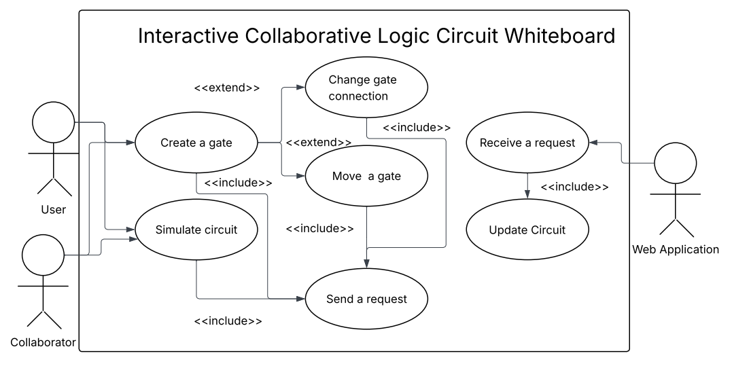
Figure 1 Use Case Diagram. It illustrates the role-based interactions in the application and how does the system answer to the requests made by the users.
2.2. Product Features
The Interactive Collaborative Logic Circuit Whiteboard provides several core features that support both individual and collaborative work on digital logic design. The system enables real-time collaborative editing, allowing multiple users to interact with the same circuit simultaneously. Changes made by one user, such as adding or modifying components, are reflected to all other participants with minimal delay. Users can perform logic circuit creation by placing standard digital components such as AND, OR, and NOT gates on a shared canvas and connecting them using wires. This visual approach allows users to construct complex circuits intuitively. Another key feature is Boolean expression conversion, where users can input logical expressions in textual form. The system automatically generates an equivalent circuit representation, reducing manual effort and minimizing errors. The system also supports real-time circuit simulation, continuously evaluating the logical output of the circuit as modifications are made. This allows users to immediately verify correctness. Finally, the application includes session management, enabling users to create, join, and participate in shared workspaces using unique session identifiers.
2.3. User Classes and Characteristics
The primary user class is students, who will use the system frequently during coursework and laboratory sessions. They require an intuitive interface and fast system response to efficiently design and test logic circuits. The secondary user class is instructors, who may use the system to demonstrate concepts and manage collaborative sessions. These users may require additional privileges, such as controlling or resetting shared workspaces. A third user group includes developers and testers, who interact with the system to verify functionality, performance, and correctness.
2.4. Operating Environment
The software will operate mainly on desktop web browsers like Mozilla Firefox, Microsoft Edge, Google Chrome and other chromium-based browsers. Because of that, the software will require internet connection.
2.5. Design and Implementation Constraints
The system must operate within a web browser environment, limiting implementation to web technologies such as JavaScript, HTML, and CSS. Real-time collaboration requires the use of low-latency communication protocols (e.g., WebSockets) to ensure timely synchronization between users. The system must support multiple concurrent users, which imposes performance constraints on synchronization and simulation mechanisms. Additionally, the application must maintain compatibility with major web browsers and be designed to allow future extensions without significant architectural changes.
2.6. User Documentation
At the start of the application, the user will be able to select a button that shows a tutorial on how to use the software.
2.7. Assumptions and Dependencies
The system will require users to login using their student credentials through the Central Authentication Service of TUL.
3. System Features
The system shall enable users to easily create various logic circuits in real time with other users. The following class diagram shows the basic functionality of the system, and the relationships within the system.
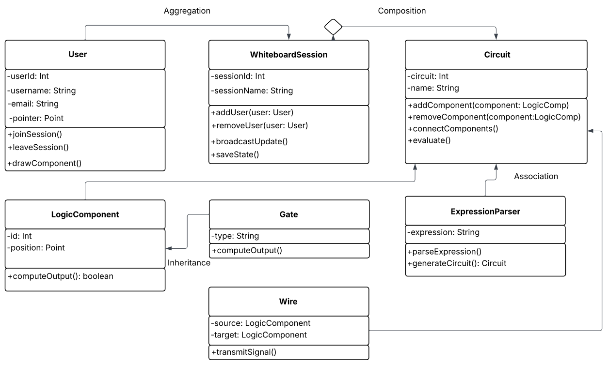
Figure 2 UML Class Diagram, illustrates the relationships of different system components.
3.1. Real-time Collaboration
Allows multiple users to edit the same circuit simultaneously.
3.2. Expression Conversion
Converts Boolean expressions into logic circuits.

3.3. Circuit Simulation
Evaluates logic output dynamically.
4. External Interface Requirements
4.1. User Interfaces Overview
The system provides a graphical user interface (GUI) accessible through a web browser. Users interact with the application using standard input devices such as a mouse and keyboard.
The main interface consists of a shared whiteboard canvas, where users can visually construct logic circuits. Users can drag and drop logic gates (e.g., AND, OR, NOT) from a toolbar onto the canvas and connect them using wires. Each action performed by a user is reflected in real time for all participants in the same session.
At the top of the interface, a navigation bar provides options for session management, including creating a new session, joining an existing session via a URL, and leaving the session. The interface also includes an input field where users can enter Boolean expressions, which are automatically converted into circuit diagrams displayed on the canvas.
The system provides real-time feedback, such as:
- Immediate visual updates when components are added, modified, or removed
- Dynamic highlighting of selected elements
- Error messages when invalid Boolean expressions are entered
- Output values displayed near circuit output nodes during simulation
The interface follows standard GUI conventions, including:
- Click-based interaction for selecting and placing components
- Drag-and-drop functionality for positioning elements
- Context menus or buttons for deleting or modifying components
Error messages are displayed clearly and concisely, typically near the relevant input field or as overlay notifications. The interface is designed to be intuitive and responsive, ensuring usability for both beginners and advanced users.
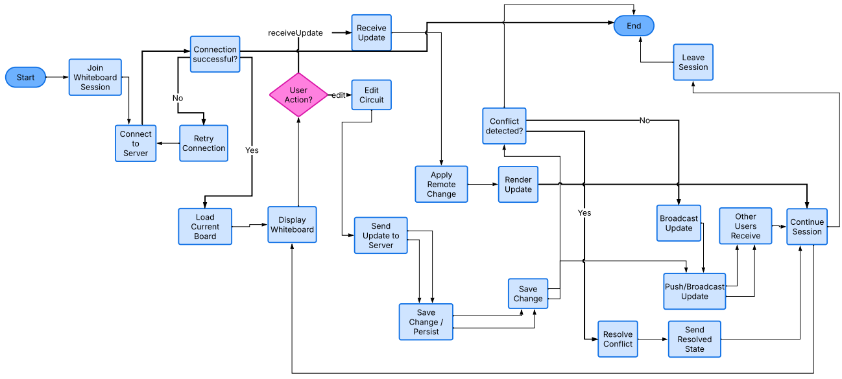
Figure 3 Activity Diagram, illustrating how does the backend work in a simplified way.
4.2. Hardware Interfaces
The system does not require specialized hardware and operates on standard user devices such as desktop computers and laptops. The primary hardware interfaces include:
- Input devices: mouse and keyboard for interacting with the graphical interface
- Display devices: monitors used to render the web-based interface and visual circuit representations
The system relies on the client device’s graphical capabilities to render the interactive whiteboard using web technologies such as HTML5 Canvas or SVG. No direct low-level hardware communication is required. All interactions between the user and the system occur through the web browser environment. Network hardware (e.g., Wi-Fi or Ethernet adapters) is required to support real-time communication between users.
4.3. Software Interfaces
The system interacts with several software components and technologies to provide its functionality. On the client side, the application runs within a web browser such as Google Chrome, Mozilla Firefox, or Microsoft Edge. It uses standard web technologies including:
- HTML, CSS, and JavaScript for rendering the user interface
- Canvas or SVG APIs for drawing and manipulating circuit elements
For real-time collaboration, the system uses WebSocket-based communication to exchange updates between clients and the server with minimal latency. On the server side, the system may use:
- A backend runtime environment (e.g., Node.js)
- WebSocket libraries (e.g., Socket.IO) to manage real-time communication
- Optional database systems (e.g., MongoDB or PostgreSQL) for session persistence
Data exchanged between components includes:
- User actions (e.g., adding gates, connecting wires)
- Session management data (e.g., session IDs, user connections)
- Circuit structure representations
- Boolean expressions entered by users
All communication between client and server follows a structured message format (e.g., JSON). The system ensures synchronization of shared data across all connected users in real time.

5. System Features/Modules
5.1. Real-time Collaboration
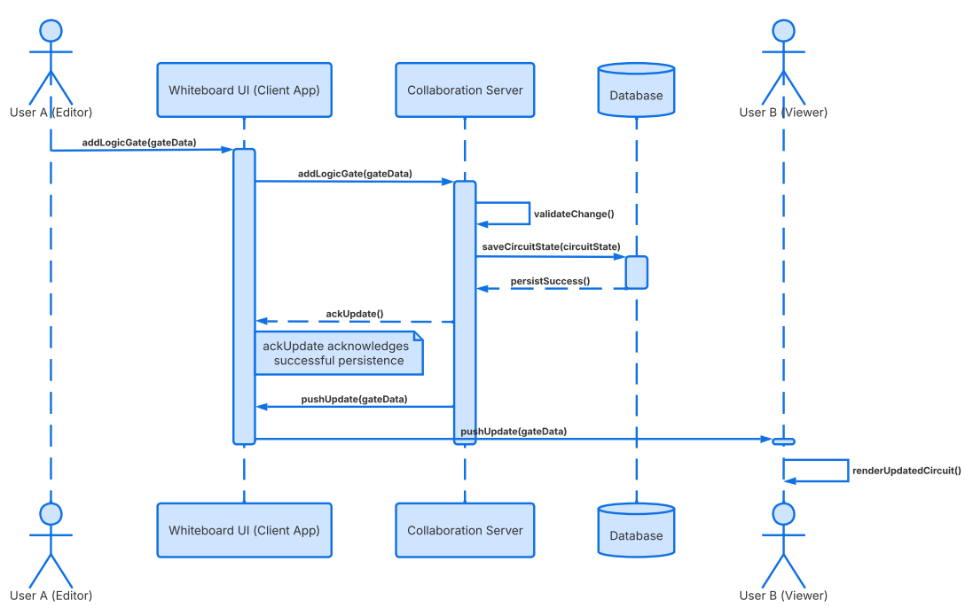
Figure 4 Sequence Diagram, showing how does real-time collaboration work between different sides of the software.
5.1.1 Description and Priority
Multi-user editing of a shared workspace. Priority: High.
5.1.2 Stimulus/Response Sequences
The user makes a change on a whiteboard
Response: The change is visible for all other students
5.1.3 Functional Requirements
FR-1.1: The system shall allow a user to create a session identified by a unique URL.
FR-1.2: The system shall allow a user to join a session using a valid URL.
FR-1.3: The system shall synchronize gate placement across users within 500 ms.
FR-1.4: The system shall synchronize wire connections across users within 500 ms.
FR-1.5: The system shall update the canvas for all users when a component is deleted within 500 ms.
5.2. Expression to Circuit Conversion
5.2.1 Description and Priority
Automatic transformation of Boolean expressions to logic circuits. Priority: Medium.
5.2.2 Stimulus/Response Sequences
The user inputs a Boolean expression
Response: The algorithm prints a logic circuit on the whiteboard on an unoccupied place.
5.2.3 Functional Requirements
FR-2.1: The system shall accept a Boolean expression as input text.
FR-2.2: The system shall generate a logic circuit from a valid Boolean expression within 4 seconds.
FR-2.3: The system shall display an error message within 1 second if the expression is invalid.
5.3. Circuit Evaluation
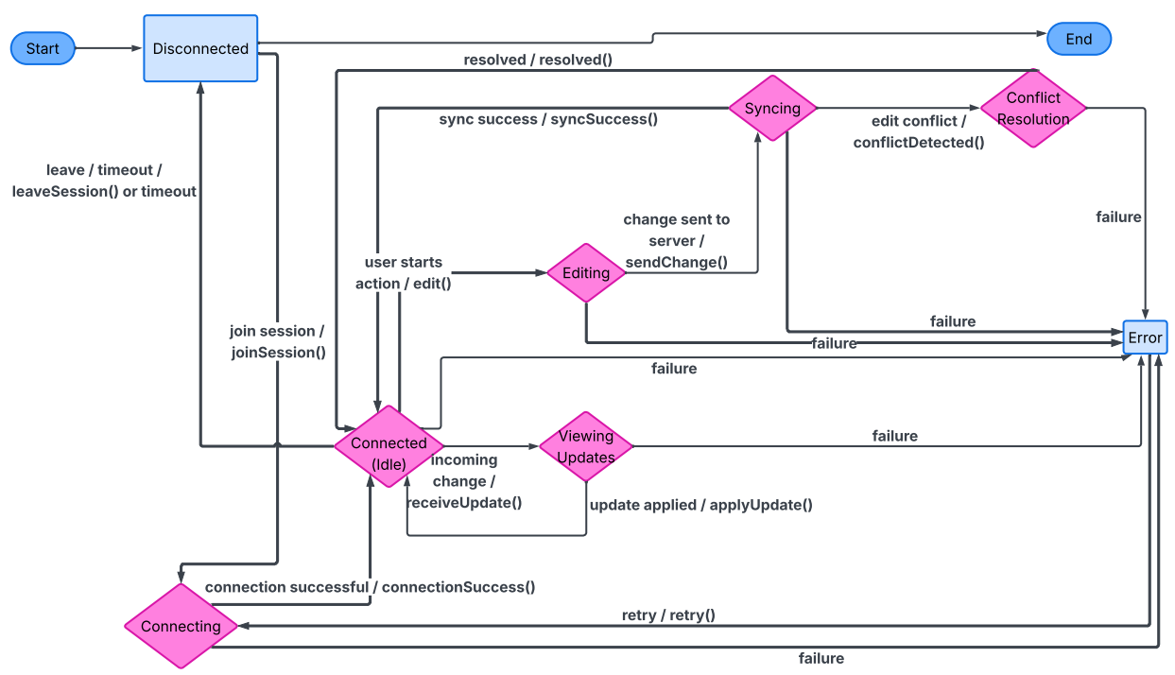
Figure 5 State Diagram, illustrating how does the circuit evaluation and connection work.
5.3.1 Description and Priority
Evaluate circuit options. Priority: Medium.
5.3.2 Stimulus/Response Sequences
The user selects a gate
Response: The software suggests a compatible gate.
5.3.3 Functional Requirements
FR-3.1: The system shall compute output values after any circuit change within 1 second.
FR-3.2: The system shall display output values for all output nodes.

6. Nonfunctional Requirements
6.1. Performance
NFR-1.1: The system shall support at least 10 concurrent users in a session.
NFR-1.2. The system shall process user actions within 500 ms.
6.2. Security
NFR-2.1: The system shall restrict session access to users possessing a valid session URL.
6.3 Reliability
NFR-3.1. The system shall maintain 99% uptime during operation hours.

